

NOVAC TECHNOLOGY SOLUTIONS

User Manual

Document Version No.: 1.00

Revision History
Version No | Reason For Changes | Author | Approver
0.01 | Draft
1.00 | Reviewed & Approved the User Manual |  | NIJANTHAN PL

Table of Contents
1. Introduction 4
2. Master CTPL Proposal & Policy Generation 4

Introduction

The document is prepared to understand and build an application for Fleet master CTPL Insurance to the insured.

Fleet Master Proposal & Policy Generation

Path: Engineering -> Master Policy Dashboard
Screen Code: S0520

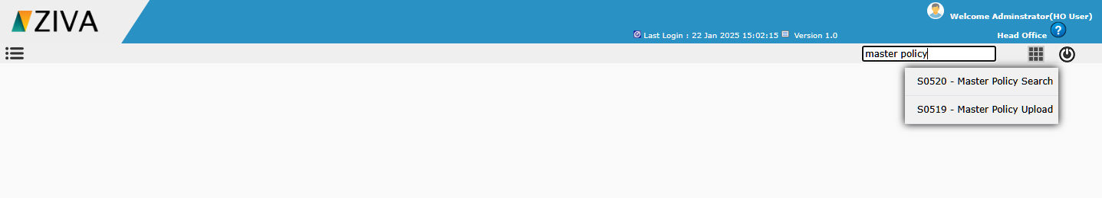

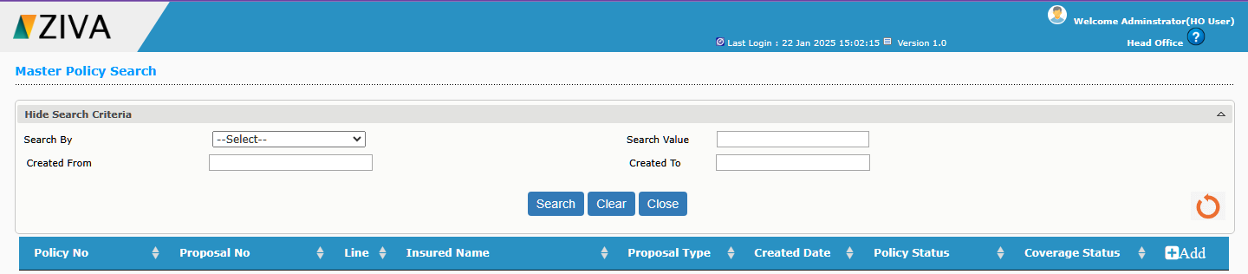
After selecting the sub Line and policy type details, on clicking Go button, remaining fields to capture the proposal details will be displayed.
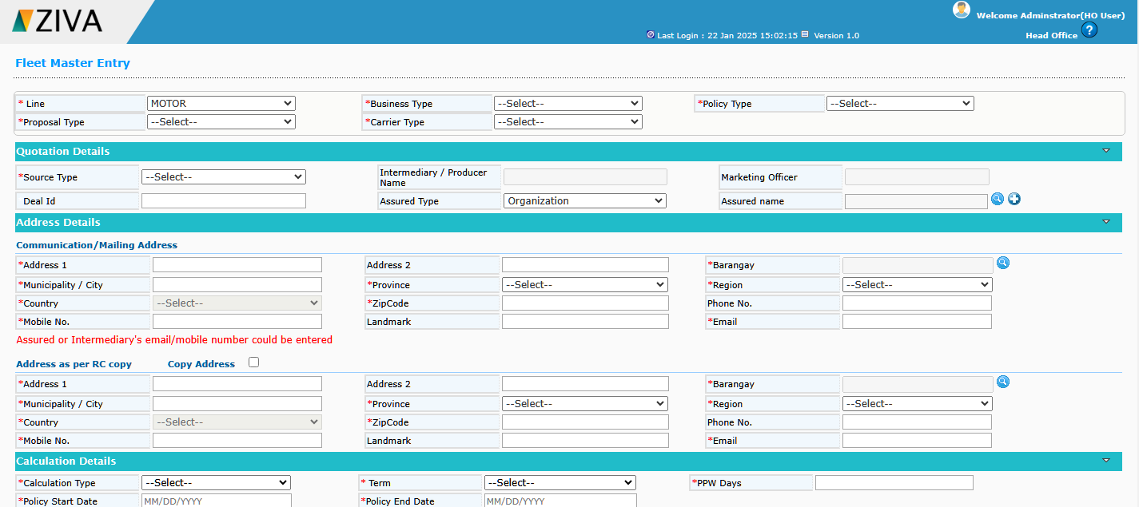

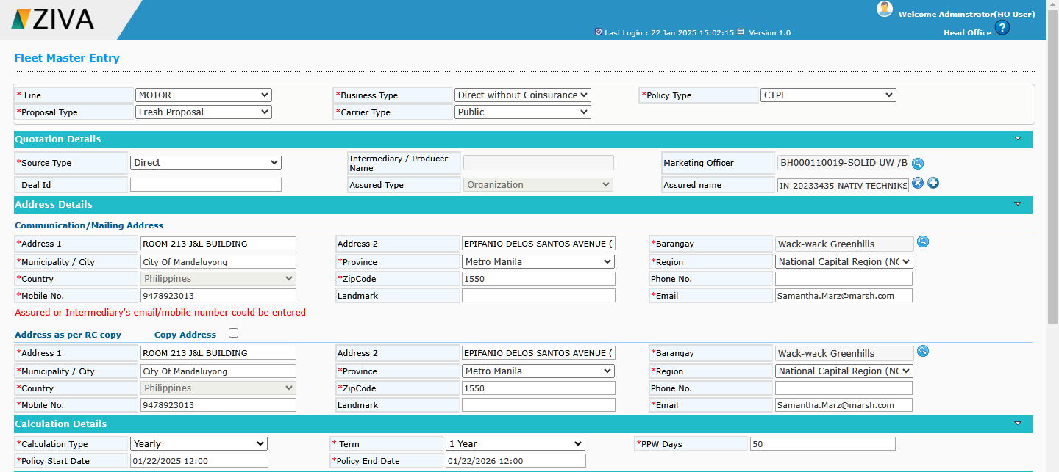

In Contractor details, click on Add new Contract icon, user can able to create a new contract. 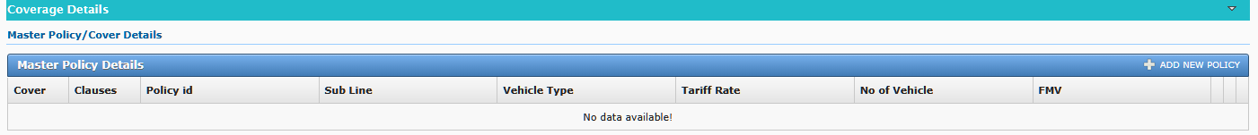
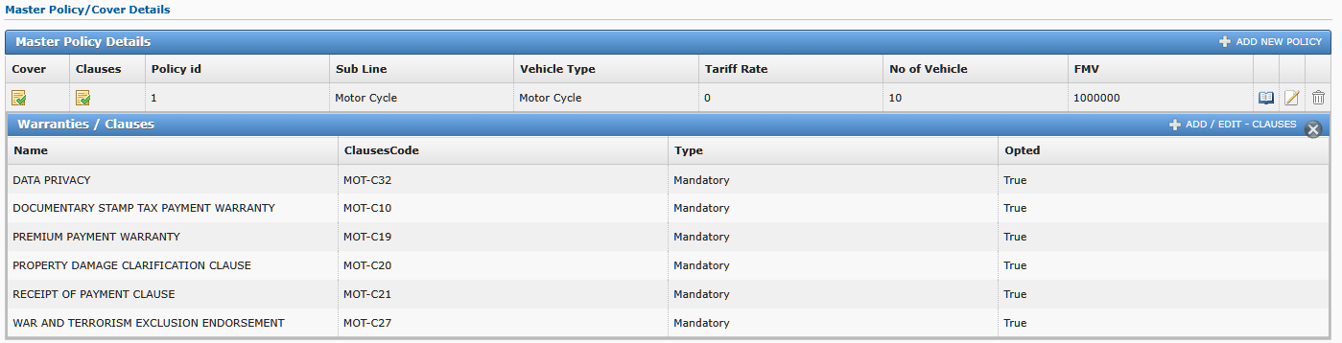

On clicking Save button, system add the contractor details. In the contractor details on clicking Sub Contractor icon, user can able to create multiple sub contractor.

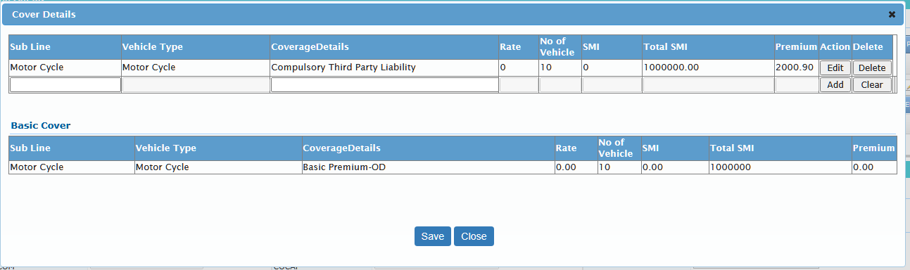

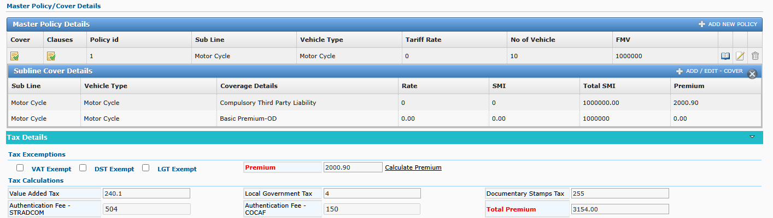

Click on Location icon to add the risk location details. Then enter the SMI and cover details for the respective location.
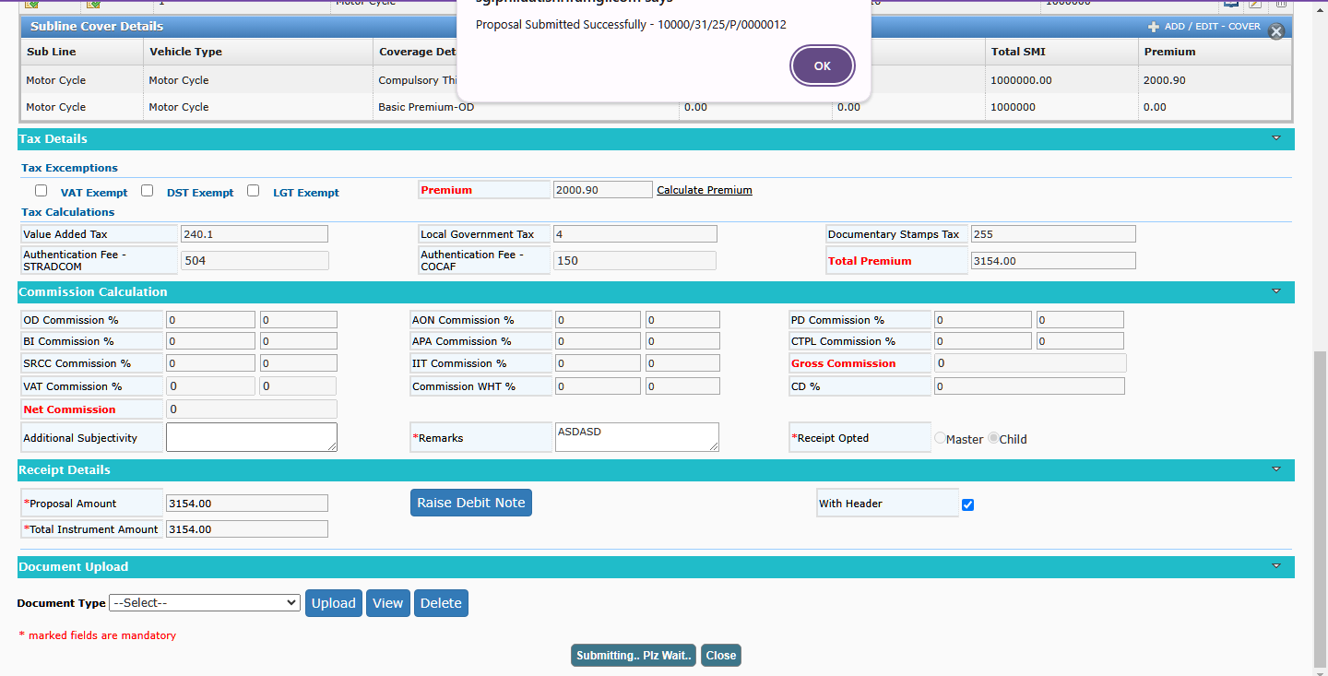

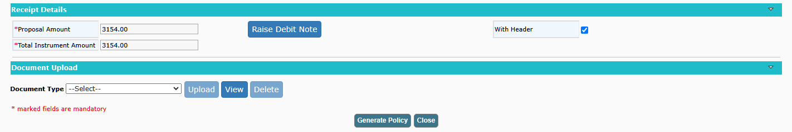
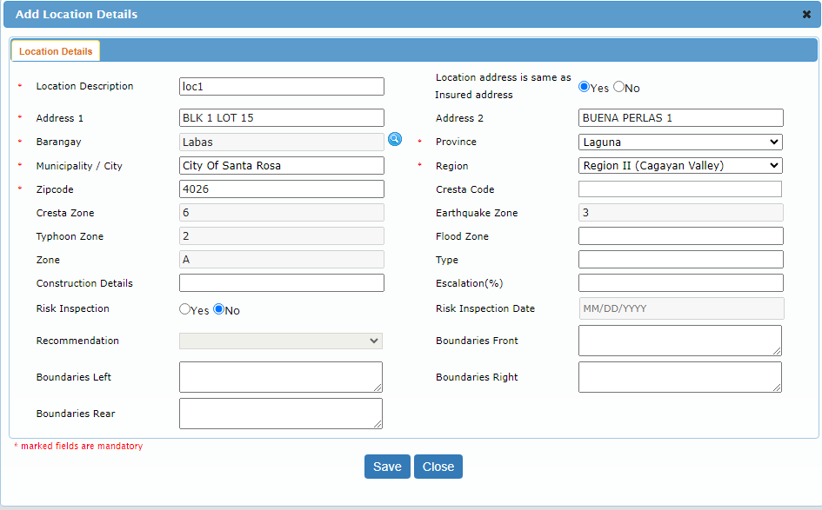
10000/31/25/000007
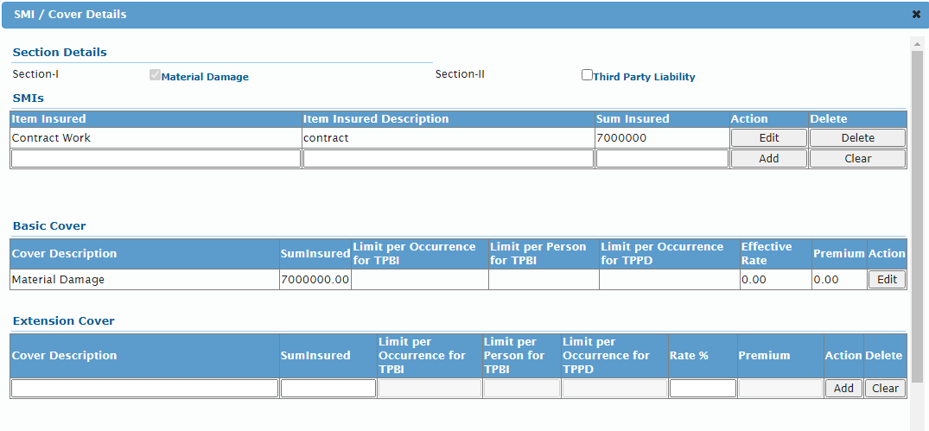
User can able to add the Mortgagee details for the location by clicking the mortgagee icon.

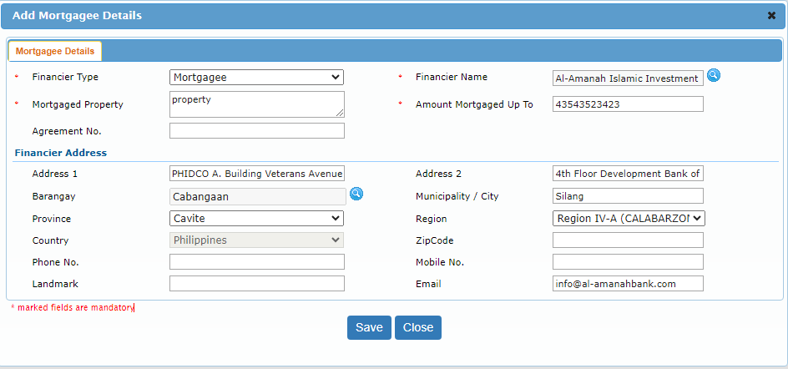

After entering all the details and click on calculate premium user can generate a Quote and then covert a proposal and generate a CAR policy.

